MANCHESTER BRIDGE CLUB
from 2nd January 2018
to
The Card Room, Grosvenor Casino,
Parrs Wood Entertainment Centre.
Wilmslow Road, M20 5PG

Our luxurious new venue will hold all Duplicates, Teams Activities & Teaching Events
with all usual sessions starting from Tuesday 2nd January 2018.
There is plenty of parking right outside the venue including disabled bays
and entrance to the Card Room is free for all bridge players.
If you have any queries please contact Jeff on 0161 445 3712
or email jeff@manchesterbridge.co.uk
HOW TO GET TO THE NEW MANCHESTER BRIDGE CLUB VENUE

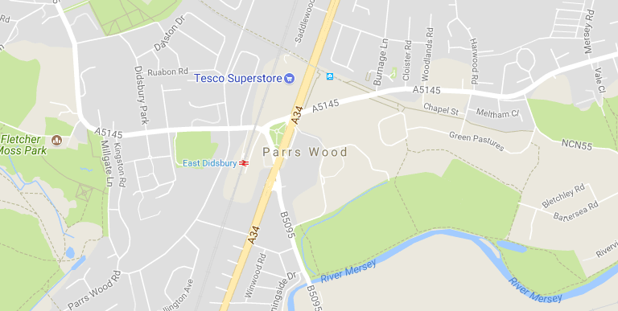

By Car The postcode for the The Grosvenor Casino at Parrs Wood is M20 5PG. It is located on the left just off the main A34 (Kingsway) around 5 miles from Manchester City Centre in Didsbury, with free parking and disabled bays available for their customers.

By Train Parrs Wood is also just a short walk from East Didsbury train station and the Metrolink.

By Bus There are regular public transport links on routes 50, 142, 42, 42a, 45a from Manchester city centre.
“We look forward to seeing you here in the New Year!”

