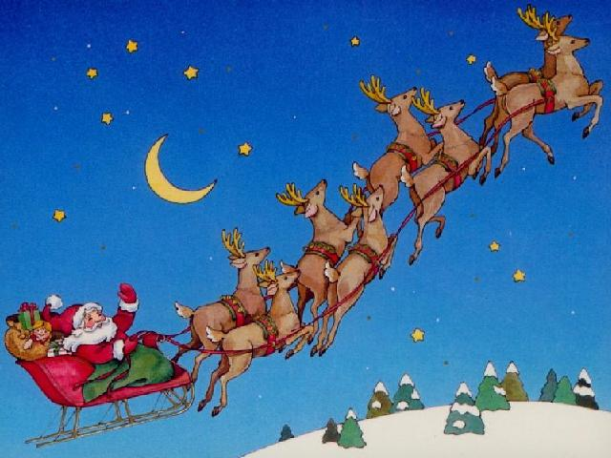
SANTA CLAUS PAIRS
SUNDAY 15th DECEMBER
- 30pm for prompt 2pm start
This is a Two Session Pairs Event.
Festive drink on arrival
The highlight between sessions is always our
SUMPTUOUS CHRISTMAS BUFFET
CASH PRIZES!
Coffee / Tea & Mince Pies during the prize giving…
….and everyone goes home with a gift!
Entry fee: £30 per player
Entries to Dave Debbage at Manchester Bridge Club,
81 Wellington Road, Fallowfield, Manchester M14 6BN
Tel: 0161 445 3712 or 07717 252114
e-mail: daviddebbage@hotmail.co.uk
LIMITED ENTRIES - PLEASE BOOK EARLY

