Learn to play Bridge
at Manchester Bridge Club
- Learn to play bridge in a friendly atmosphere in one of the most prestigious clubs in the country.
- No partner necessary.
- No previous experience necessary
Lessons
10 week course starting on Monday 23rd September at 10.30am. Just £7 a lesson.
Venue: Manchester BC, 81 Wellington Road, Fallowfield, M14 6BN

For more information or to reserve a place contact: Irene Davies on 07968857467 or irenedavies14@gmail.com
For more information about evening
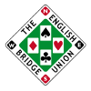
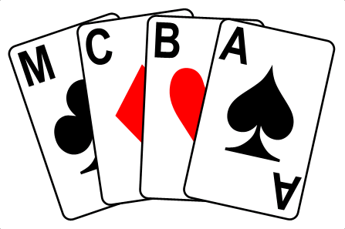
Lessons contact Dave at 0161 4453712
or at davedebbage@hotmail.co.uk

