THE WELSH FOURSOMES
TWO DAY GREEN POINTED TEAMS
14TH & 15TH SEPTEMBER 2019
Saturday 12:00 short break about 3:30
Sunday 11:00 short break about 2:30
NEW VENUE
St Margaret’s Church Hall,
Chester Road, Wrexham, LL11 2SH

MULTIPLE TEAMS
FORMAT DEPENDENT ON ENTRY

ENHANCED GREEN POINTS FOR MATCH WINS AND RANKING & PRIZE MONEY (Approx 40% of entry fees)
Director: Matt Foster
Entries £160 per team to P. Murphy
Paypal - LFFbridge@gmail.com
Cheques payable to P. Murphy, School of Natural Sciences, Bangor, LL57 2UW.
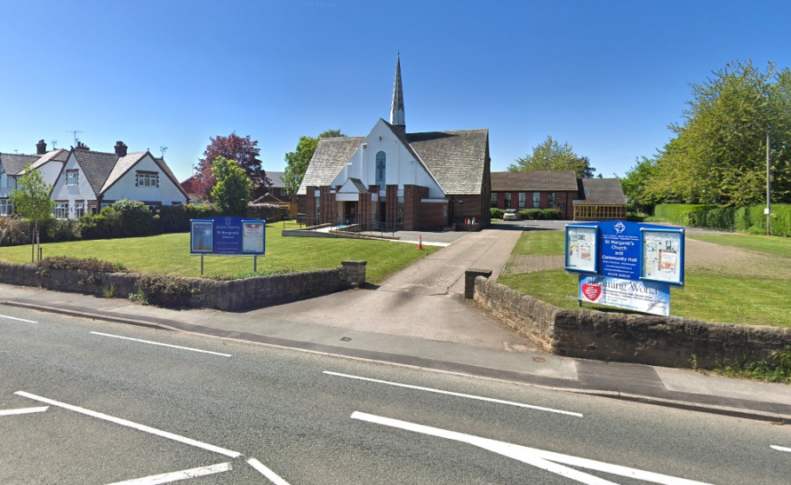
Venue
St Margaret’s Church Hall,
Chester Road,
Wrexham
LL11 2SH
Emergency phone
07816 333439
Bring your own food or meals available across the road at The Acton Park (best to order in advance of break)
Many local hotels - a few examples.
