Manchester Marriott Victoria & Albert Hotel
Water Street, Manchester M3 4JQ United Kingdom

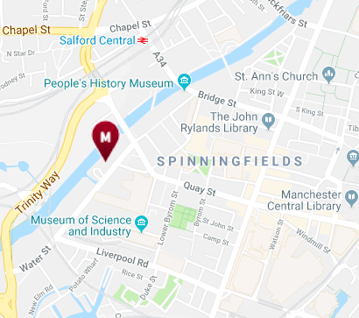
The Victoria and Albert Hotel is situated at the northern end of Water Street (B5225), close to the old Granada Studios. There is parking at the hotel. See the MCBA website for further details about other car parks.
There are various restaurants and cafes in Spinningfields and the area between the hotel and Deansgate.
The Manchester County Bridge Association would like to thank Altrincham Bridge Club, Manchester Bridge Club,MSB, Cheadle Hulme Bridge Club and Larkhill Bridge Club for their help and support

BACS
To Pay by BACS: SC: 01-07-20
AC: 41526708 (MCBA)
Ref: Congress 2020
Manchester County Bridge Association
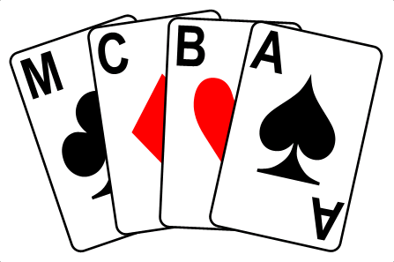
The Manchester
Congress
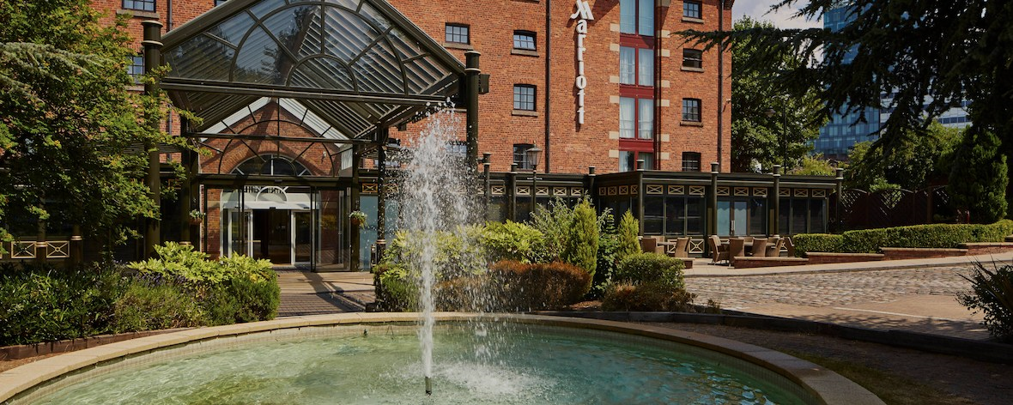
Saturday 4th & Sunday 5th January 2020

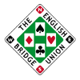
At the Manchester Marriot Victoria and Albert Hotel.
Water Street, Manchester M3 4JQ
Reservations: 0161 832 1188
Congress Enquiries.
Jeff Smith. Email: jasmith@nildram.co.uk
Tel. no. 07976 794390
A Congress for all players
Saturday 4th January Championship Pairs
12 midday – 7.30pm
There will be a 45 minute break between the two sessions.
This is a multiple pairs event playing for the Michelle Brunner Trophy. Prizes also for mixed, ladies and men’s pairs and Intermediate pairs (NGS Jack and Regional master or below.)
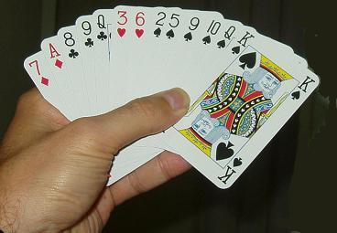

Sunday 5th January Championship Teams
11am – 7pm
This is a two session multiple teams event with 3 finals in the second session. Playing for the Bernard Goldenfield Trophy.
Michaels Trophy is also awarded to the leading Junior player
. There is a Jack High, one session duplicate each day running alongside the main Congress

Entry Forms
Championship Pairs

Name……………………………………………………………………………………………………….
Address……………………………………………………………………………........................
…………………………………………………………………………………………………..
Email………………………………………………………………………………………………………
Tel.No…………………………………………………………………………………………………….
Partner…………………………………………………………………………………….
Championship Teams
Name……………………………………………………………………………………………………….
Address…………………………………………………………………………………………………..
………………………………………………………………………………………………….
Email……………………………………………………………………………………………………..
Tel No……………………………………………………………………………………………………
Team Names………………………………………………………………………………………….
Entry fee £25 per player per day or £45 for the full congress. Under 25’s Half Price
Please make cheques payable to M.C.B.A.. Send cheques(s) and completed forms to:- Jeff Smith, 28 Windsor Road. Prestwich, M25 0FF. You can pay by BACS – details on back page.
Licensed by the EBU, Master Points awarded, generous prizes.

