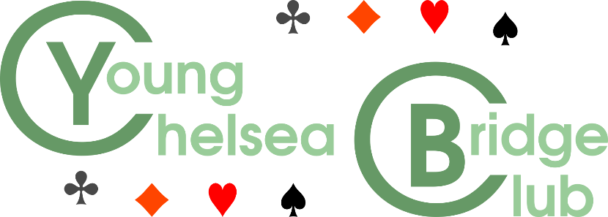
––

The YCBC is delighted to announce the launch of this prestigious new event
August Bank Holiday 2021
to be held in the new
London MindSports Centre
– the new home of the Young Chelsea BC next to Ravenscourt Park tube station –
Double-elimination teams-of-four
Limited to 16 teams
Full details to follow
All proceeds in aid of Youth Bridge
Only a few places left
Register your interest NOW
manager@ycbc.co.uk

Systems allowed: EBU level 5
Chief Tournament Director: Phil Godfrey
Referees: Heather Dhondy, Tom Townsend
Seeding Committee: Sally Brock, Heather Dhondy, Tom Townsend, Mike Bell

licensed by the English Bridge Union

