Martin Taylor’s team beat the seeded Rosen team in the semi-final of the Hubert Philips Bowl this week. The team was Barbara, Justin and Jason Hackett with Martin. The Hubert Philips is the national mixed pivot teams knockout competition. Martin’s team had built a substantial lead going into the final stage which led to some very competitive bidding. An example was this board:

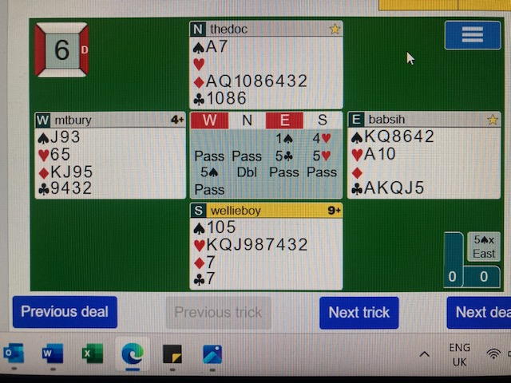

Barbara made an overtrick scoring 1050 when the opponents failed to lead a heart. At the table that felt like a good result that may have made up for a thin 6 spades bid and made by the opponents on the previous hand. As it turned out it resulted in a small loss because at the other table the final contract was 5 clubs redoubled making 12 tricks and scoring 1400! The 6 spades contract on the previous hand was a flat board.

