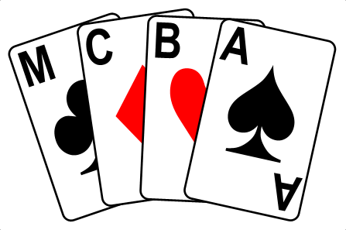
MANCHESTER CONGRESS 2024
Cresta Court Hotel, Altrincham, WA14 4DP, 6th & 7th January 2024

Non-Expert Competition for the Kevin Comrie Cup: Sunday January 7th

Face to face for the first time since Covid, this event is being held at the Cresta Court Hotel in Altrincham. It is being organised by Oliver Cowan in conjunction with MCBA. The venue provides an excellent, friendly setting for this congress with easy access to the local town centre with lots of nice restaurant and bar options for after bridge finishes.
The Congress includes Championship Pairs and Teams - each for two sessions, and on Sunday January 7th in the afternoon we are holding our Non-Expert competition for the Kevin Comrie Cup. This will be a relaxed event with about 24 boards: start time 2.30 – finish and prize giving 5.30pm.
To qualify as a Non-Expert, your NGS grading needs to be 9 or below: if you do not know your grading your club committee will be able to help. You may also play if you are not a member of the EBU.
The entry fee is £15 per player to include free parking & refreshments.
MCBA looks forward to welcoming you to the Congress.
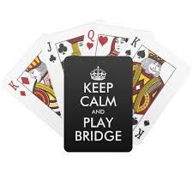
To enter, please email name and contact details to ocbridgecomps@gmail.com and send payment to sort: 404230 account: 72143569 account name: Oliver Cowan. Queries may be sent to Barbara Lewis (babsandalec@hotmail.com)

